Preface

The Company recognizes its obligation to create a safe work environment and has written and implemented this plan for the purposes of complying with the County of San Diego’s requirement for all businesses to create a Safe Reopening Plan (SRP) in the wake of the COVID-19 Pandemic.

COVID-19 Supervisor

The Company shall identify a COVID-19 Supervisor for each location. This Supervisor’s duty shall be to ensure employee and visitor compliance with this plan and other CDC recommendations.

Employee Safety

The employees of this Company are one of its greatest assets. We recognize the need to identify hazards in the workplace, and identify effective control methods. To that end, the Company has adopted the following policies and procedures to ensure employee safety as it pertains to COVID-19:
- Employees that can work remotely from their home or other secluded environments shall do so. In some cases, a “split shift” may be necessary if an employee’s physical presence is required in the workplace, but this time shall be kept to a minimum.
- Any employee showing signs of illness such as fever, chills, body aches, excessive coughing or sneezing, etc., shall report this condition to their Supervisor prior to reporting to work, and shall not report to work until the symptoms subside and the employee has the approval of their Supervisor.
- Employee temperatures shall be taken with a touchless thermometer upon reporting to work. Any employee with a temperature in excess of 100 degrees F. shall be sent home. While at home, the employee shall monitor their temperature and other symptoms, and contact the Supervisor for permission to report to work once their symptoms subside.
- Face covers shall be on the body at all times and utilized when maintaining six feet of social distance is not possible. Employees shall provide their own face cover, but the Company shall provide a face cover if an employee cannot.
- Employees shall wash their hands with soap and warm water for at least 20 seconds on a regular basis, including before and after using the restroom, before and after eating, and at two-hour intervals. Hand sanitizer containing at least 70% alcohol shall be provided by the Company at key locations, and is suitable in lieu of soap and water.
- All visitors to the Company shall be required to follow the same guidelines found in this Plan.
- Personal Protective Equipment (PPE) shall be provided by the Company and utilized by employees as a last resort hazard control method after all other control methods have been eliminated. The following hierarchy of controls shall be utilized to evaluate workplace hazards and identify effective control measures:
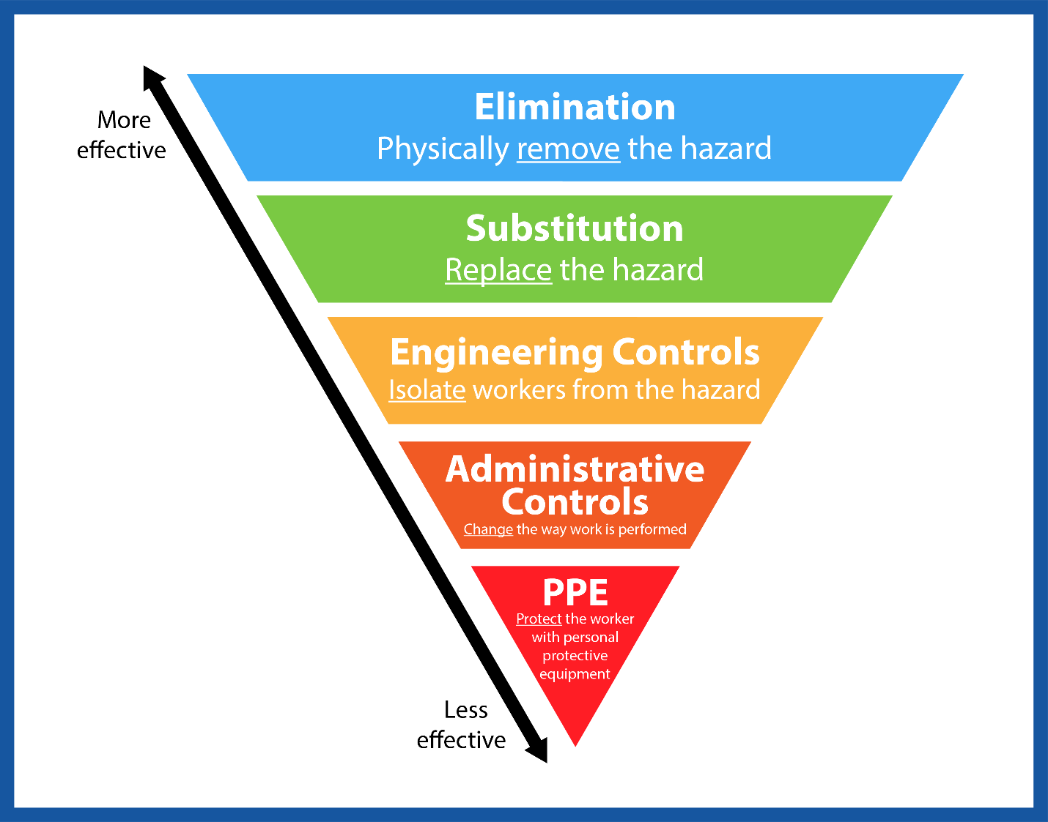

Visitor Safety

Non-employee visitation to all Company locations shall be discouraged and minimized to the extent possible. Meetings and other needs for people to congregate shall be handled on a virtual level whenever possible. Examples of visitors to Company facilities include:
- Delivery drivers
- Vendors
- Invited guests
- Inspectors
- Public agency authorities
- Union representatives
- Law enforcement

Visitors shall be required to:
- Follow CDC COVID-19 guidelines.
- Cover their faces when six feet of social distancing is not possible. The face cover shall be on the body and available at all times.
- Any visitor showing signs or symptoms of illness such as fever, chills, body aches, excessive coughing or sneezing shall be denied access.
- Visitor’s temperatures shall be taken with a touchless thermometer upon arrival, and anyone with a temperature in excess of 100 degrees F shall be denied access.
- Whenever possible, delivery and pickup needs shall be conducted on a “curbside” basis.
Sanitation

The Company shall provide adequate sanitation including:
- Ensuring access to restrooms or portable toilets.
- Plumbed hand washing facilities, portable hand washing stations, or hand sanitizer at all restroom and related facilities.
- All frequently touched surfaces shall be disinfected on a regular basis. Examples of frequently touched surfaces include:
- Equipment
- Tools
- Office machinery
- Production machinery
- Mobile equipment
- Material handling equipment
- Door handles and knobs
- Tables
- Chairs

Physical Distancing and Other CDC guidelines

All Company employees and visitors shall follow CDC COVID-19 guidelines including:
- Maintaining six feet of distance between people whenever possible.
- Positioning workstations, desks, etc. such that six feet of separation can be maintained whenever possible.
- When elevators are used, face covers shall be required of all elevator occupants. The number of occupants in each elevator shall be limited to a maximum of four people whenever possible.
- Ride sharing and carpooling shall be discouraged, and only be utilized when absolutely necessary. If two or more workers are in one vehicle, all occupants shall wear face covers.
- Occupancy of Company facilities shall be reduced to create an environment such that people can maintain six feet of social distancing whenever possible.
- One-way foot traffic throughout the workplace shall be established whenever possible.
- Workers with private offices or isolated work stations shall remain in their space with the door shut whenever possible.
Other Company Practices and Communication Requirements

The Company has developed and implemented the following:
- COVID-19 related warning signs shall be posted in conspicuous locations throughout the workplace such as entries, exists, restroom, kitchens, locker rooms, copy rooms, etc.
- A copy of this Plan shall be made available to all employees, and they shall be required to sign a written acknowledgement that they understand its contents.
- Company related travel, such as to other states and countries, shall be kept to an absolute minimum and only upon review and approval by Management. Upon the conclusion of travel activities, employees shall follow applicable CDC quarantine guidelines.

Site Specific Safe Reopening Plan
Instructions: Delete the information provided in the righthand column and replace with your Company specific information:
Date | May 6, 2020
Prepared by | Joe Safety
Company name | Expert Accounting and CPA Services
Company address | 101 A Street, San Diego, CA 92101
Phone | 619-222-2222
Describe business operations | Provider of accounting, CPA, and related services.
Name and contact information of person to contact for more information about this plan | Joe Safety  joesafety@expertaccounting.com  619-222-2222
COVID-19 Supervisor name and contact information | Suzy Safety  suzysafety@expertaccounting.com  619-222-2222
Describe how/where employee and visitor body temperature will be checked upon arrival | Upon arrival at the reception area, Receptionist shall utilize no-touch thermometer to check body temperature. Anyone with a temperature in excess of 100 degrees F. will be denied access and their name will be recorded on the Temperature Declination Log.
Location of extra face covers if needed | Reception desk
Location of handwash facilities / Hand sanitizer | Hand washing facilities located in restroom.  Hand sanitizer located at Reception desk, copy room, breakroom, and supply room.
Personal Protective Equipment (PPE) required at this location | No special PPE required with the exception of face cover.
Who is responsible for sanitizing frequently touched location and how often | Suzy Safety or Joe Safety will sanitize frequently touched surfaces at the beginning of the shift, at two-hour intervals, and at the end of the day.
Location of sanitizing supplies | Copy room
Describe how workstations have been positioned to provide for six feet of social distancing | The facility floor plan has been evaluated and workers with private offices or work stations shall remain in the space with the door closed to the extent possible. Workers in cubicle or similar areas shall be positioned such that a minimum of six feet of distance is maintained.
Where have COVID-19 notices been posted | All entries and exists, copy room, break room, and supply room.

Site Specific Safe Reopening Plan
Instructions: Delete the information provided in the righthand column and replace with your Company specific information:
Date | May 6, 2020
Prepared by | Joe Safety
Company name | Salon Services
Company address | 101 A Street, San Diego, CA 92101
Phone | 619-222-2222
Describe business operations | Provide hair and skin care services.
Name and contact information of person to contact for more information about this plan | Suzy Safety  joesafety@expertaccounting.com  619-222-2222
COVID-19 Supervisor name and contact information | Suzy Safety  suzysafety@expertaccounting.com  619-222-2222
Describe how/where employee and visitor body temperature will be checked upon arrival | Upon arrival at the reception area, staff shall utilize no-touch thermometer to check body temperature. Anyone with a temperature in excess of 100 degrees F. will be denied access and their name will be recorded on the Temperature Declination Log.
Location of extra face covers if needed | Reception desk.
Location of handwash facilities / Hand sanitizer | Hand washing facilities located in restroom and shampoo room.  Hand sanitizer located at reception desk, shampoo room, and each service room.
Personal Protective Equipment (PPE) required at this location | No special PPE required with the exception of face cover.
Who is responsible for sanitizing frequently touched location and how often | Suzy Safety will sanitize frequently touched surfaces at the beginning of the shift, at two-hour intervals, and at the end of the day.
Location of sanitizing supplies | Shampoo room.
Describe how workstations have been positioned to provide for six feet of social distancing | The facility floor plan has been evaluated and. workers with private work stations shall remain in the space with the door closed to the extent possible. Workers in other areas shall be positioned such that a minimum of six feet of distance is maintained. Users of the Shampoo room shall only occupy every other chair / station.
Where have COVID-19 notices been posted | All entries and exists, shampoo room, and supply room.
Customer access and scheduling | No waiting area will be provided. Customers will be instructed to wait in their vehicles until called or texted. Also, no “double booking” shall be allowed in that Technicians can only service one person at a time.

Temperature Declination Log
The individuals recorded below showed a body temperature in excess of 100 degrees F, and were denied access to the facility:

Date | Time | Name | Company | Temp.
Note: In order to comply with HR legal requirements, this document may only be completed by a designated representative of the company.

** This page intentionally left blank. **

